1. Launch one ec2 using Amazon Linux 2 image and add script in user data to install Apache.

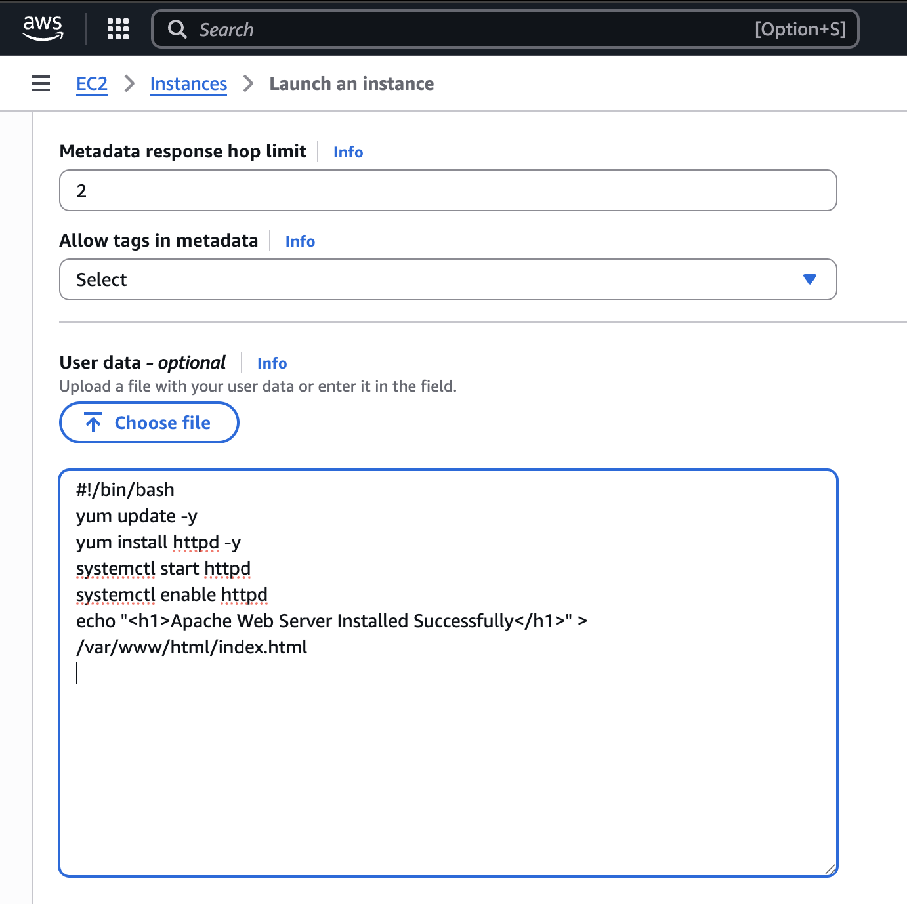

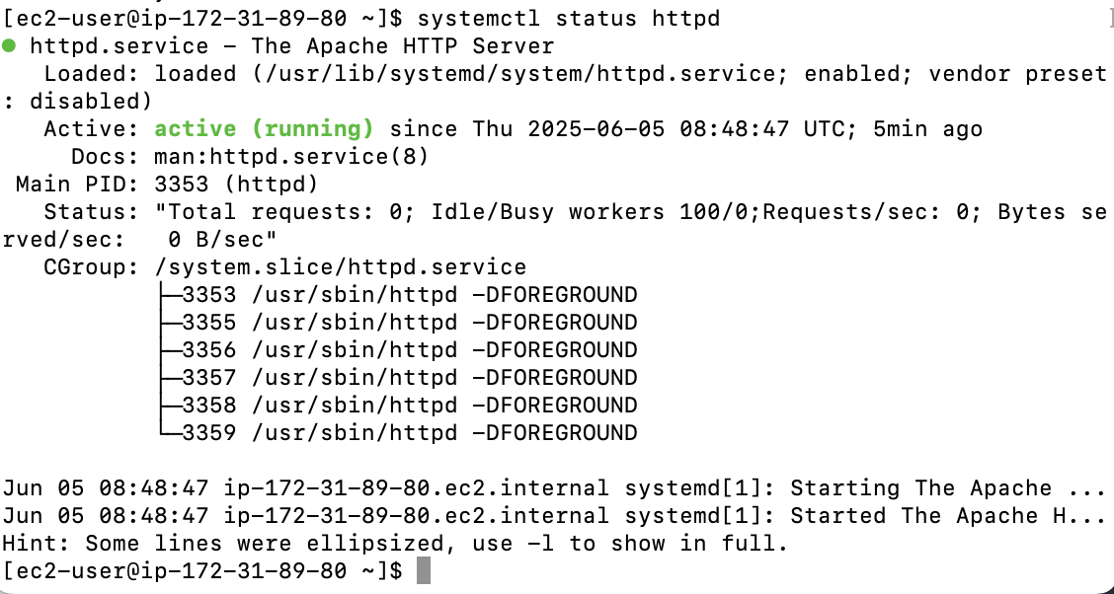

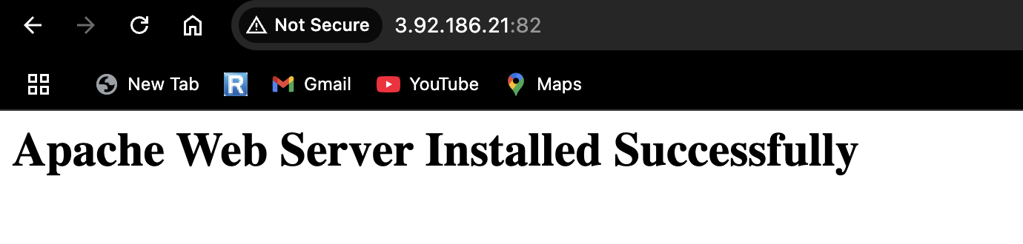

1. Launch one ec2 using Ubuntu image and add script in user data to install Nginx.

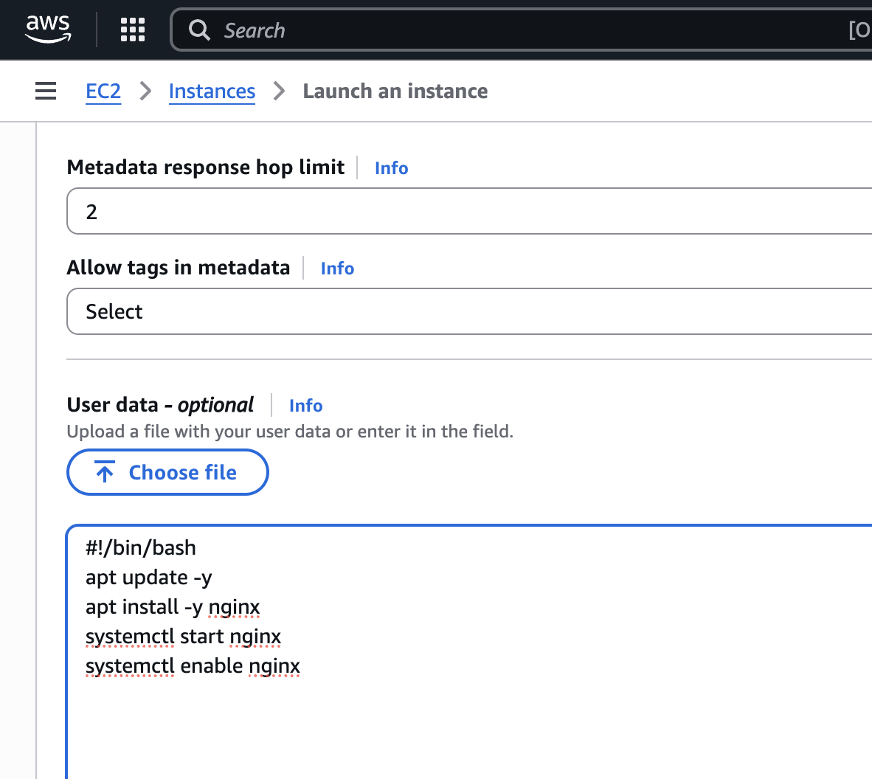

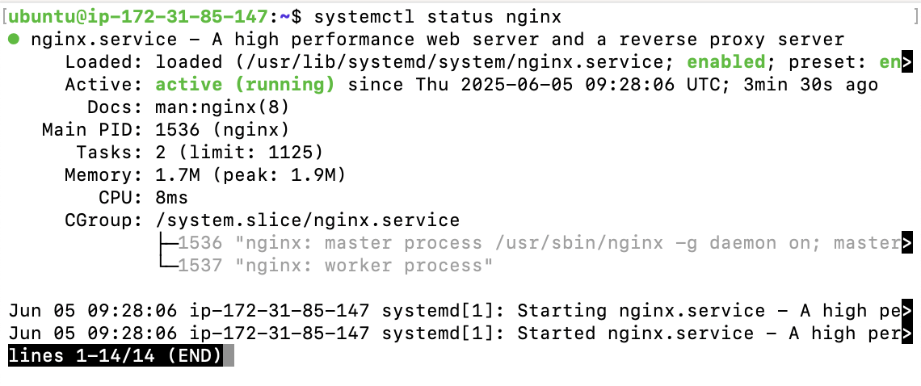

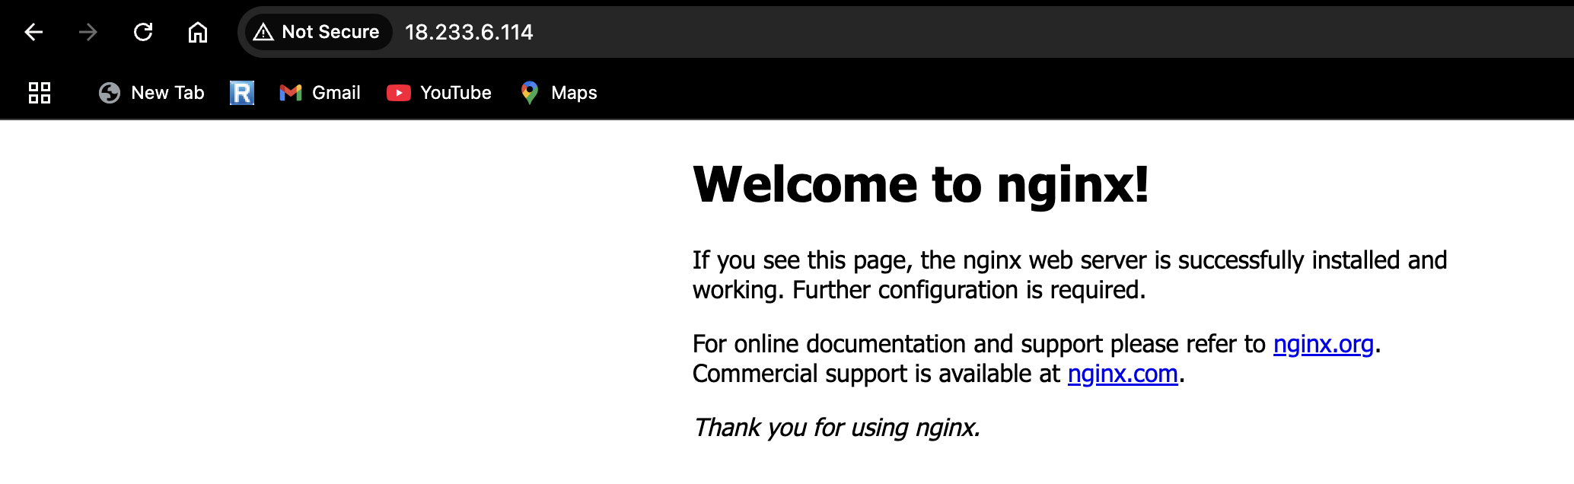

1. Launch one windows server and install tomcat in windows.



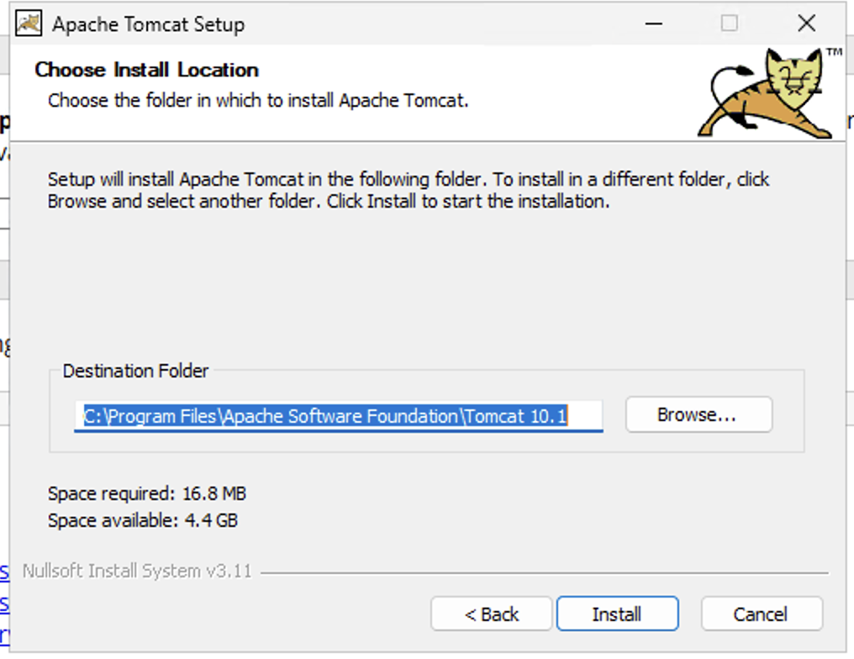

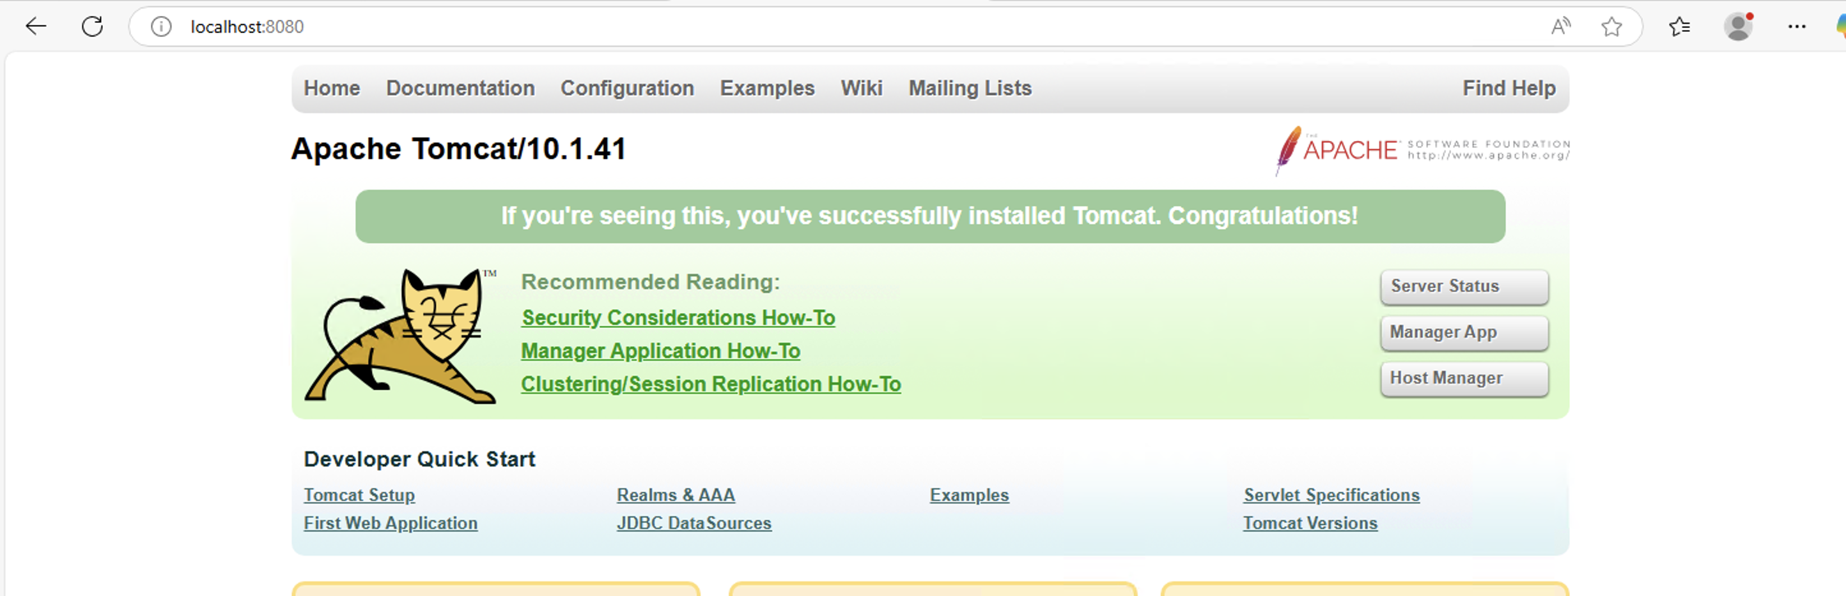

1. Take snapshot of the instance created in Task 1.

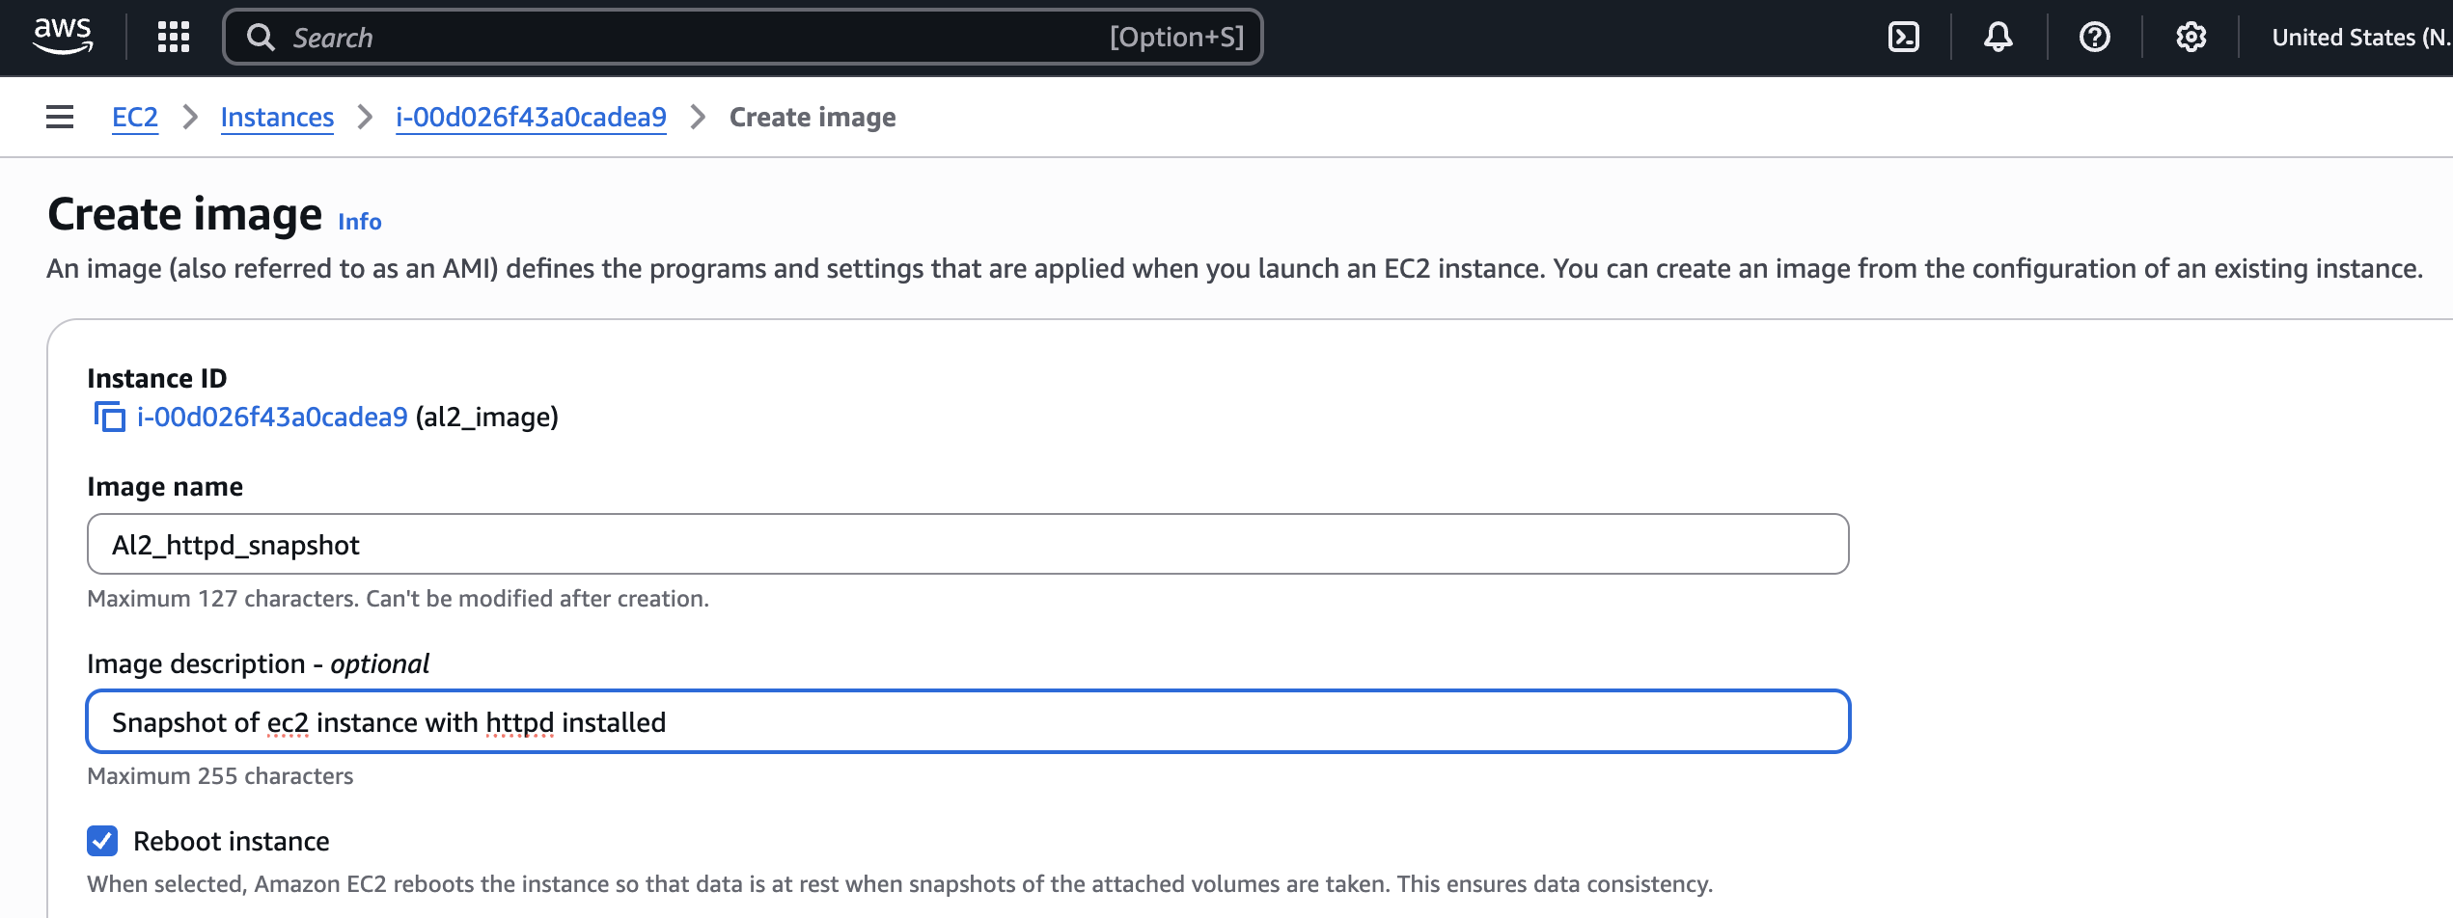

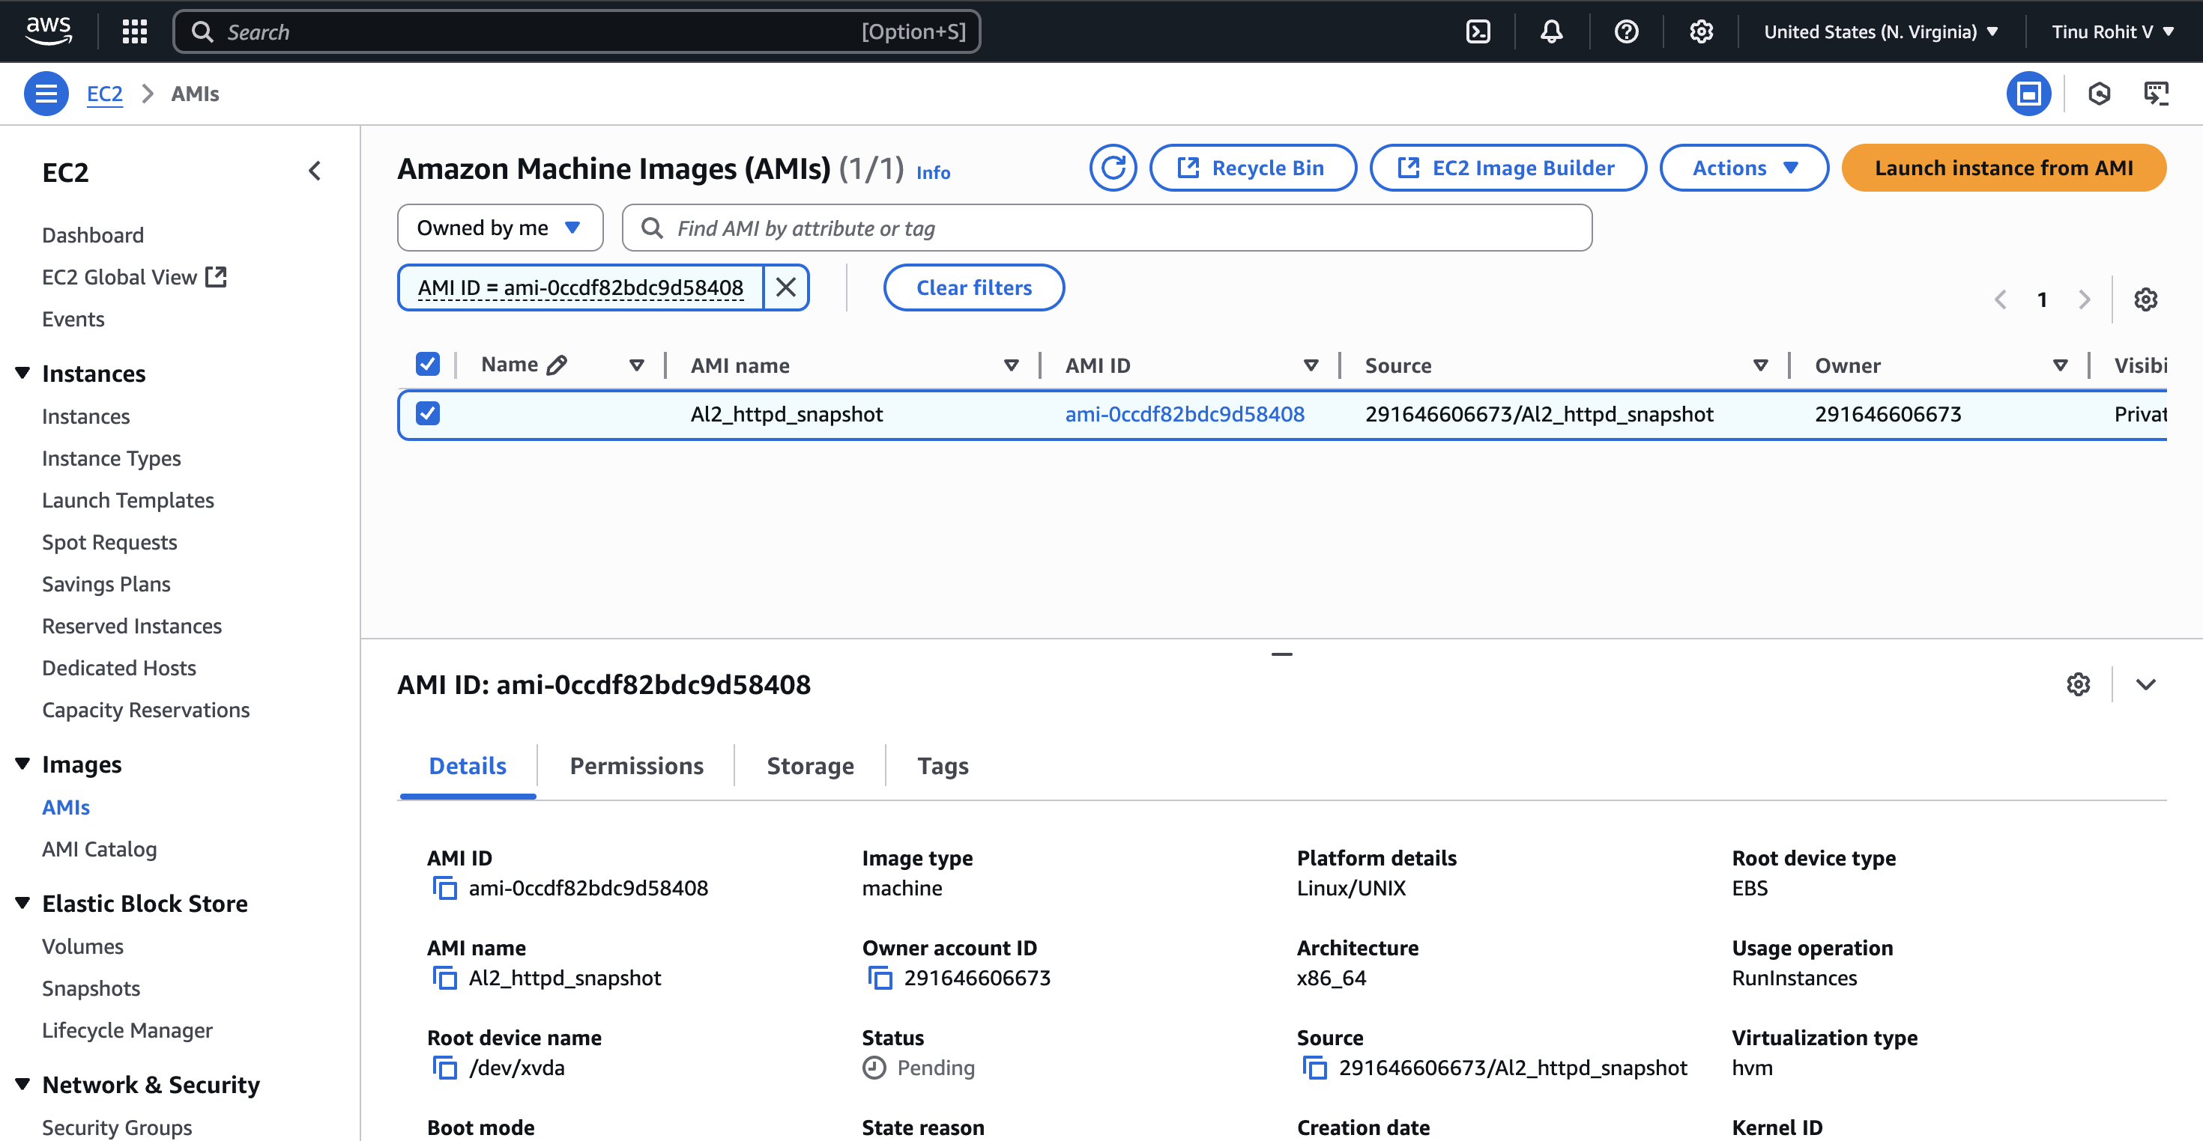

1. Assign password less authentication for ec2 created on Task 2.

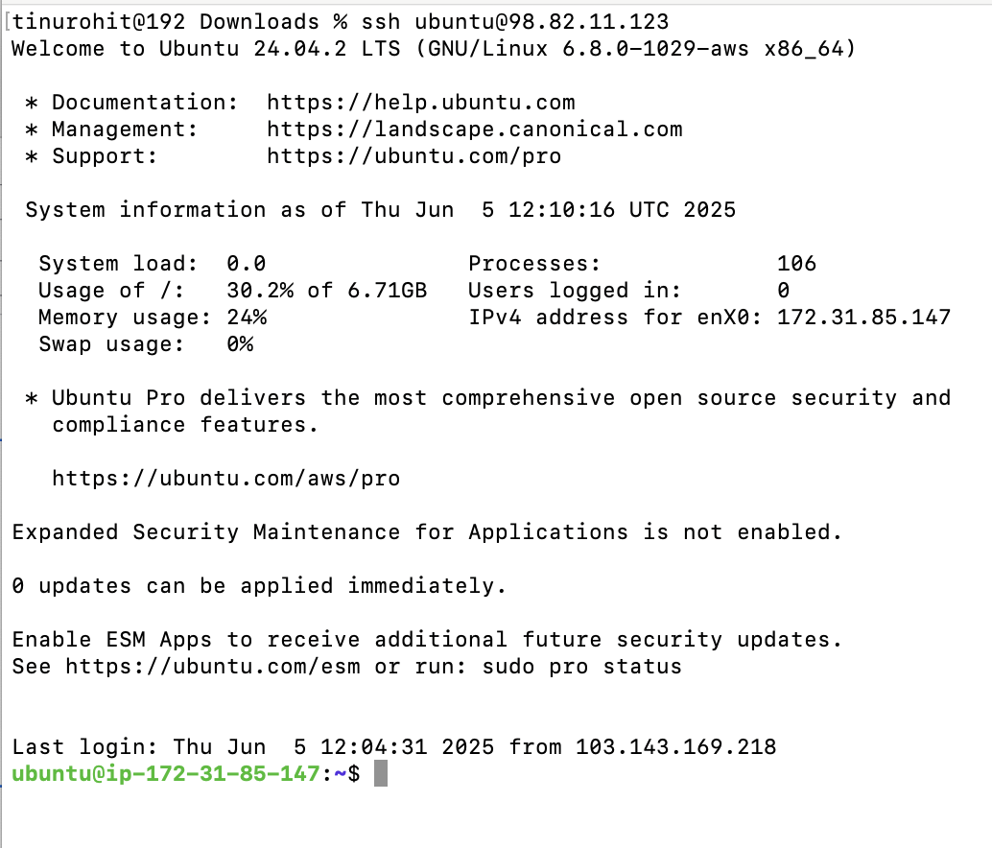

1. Launch any ec2 using spot purchasing option.

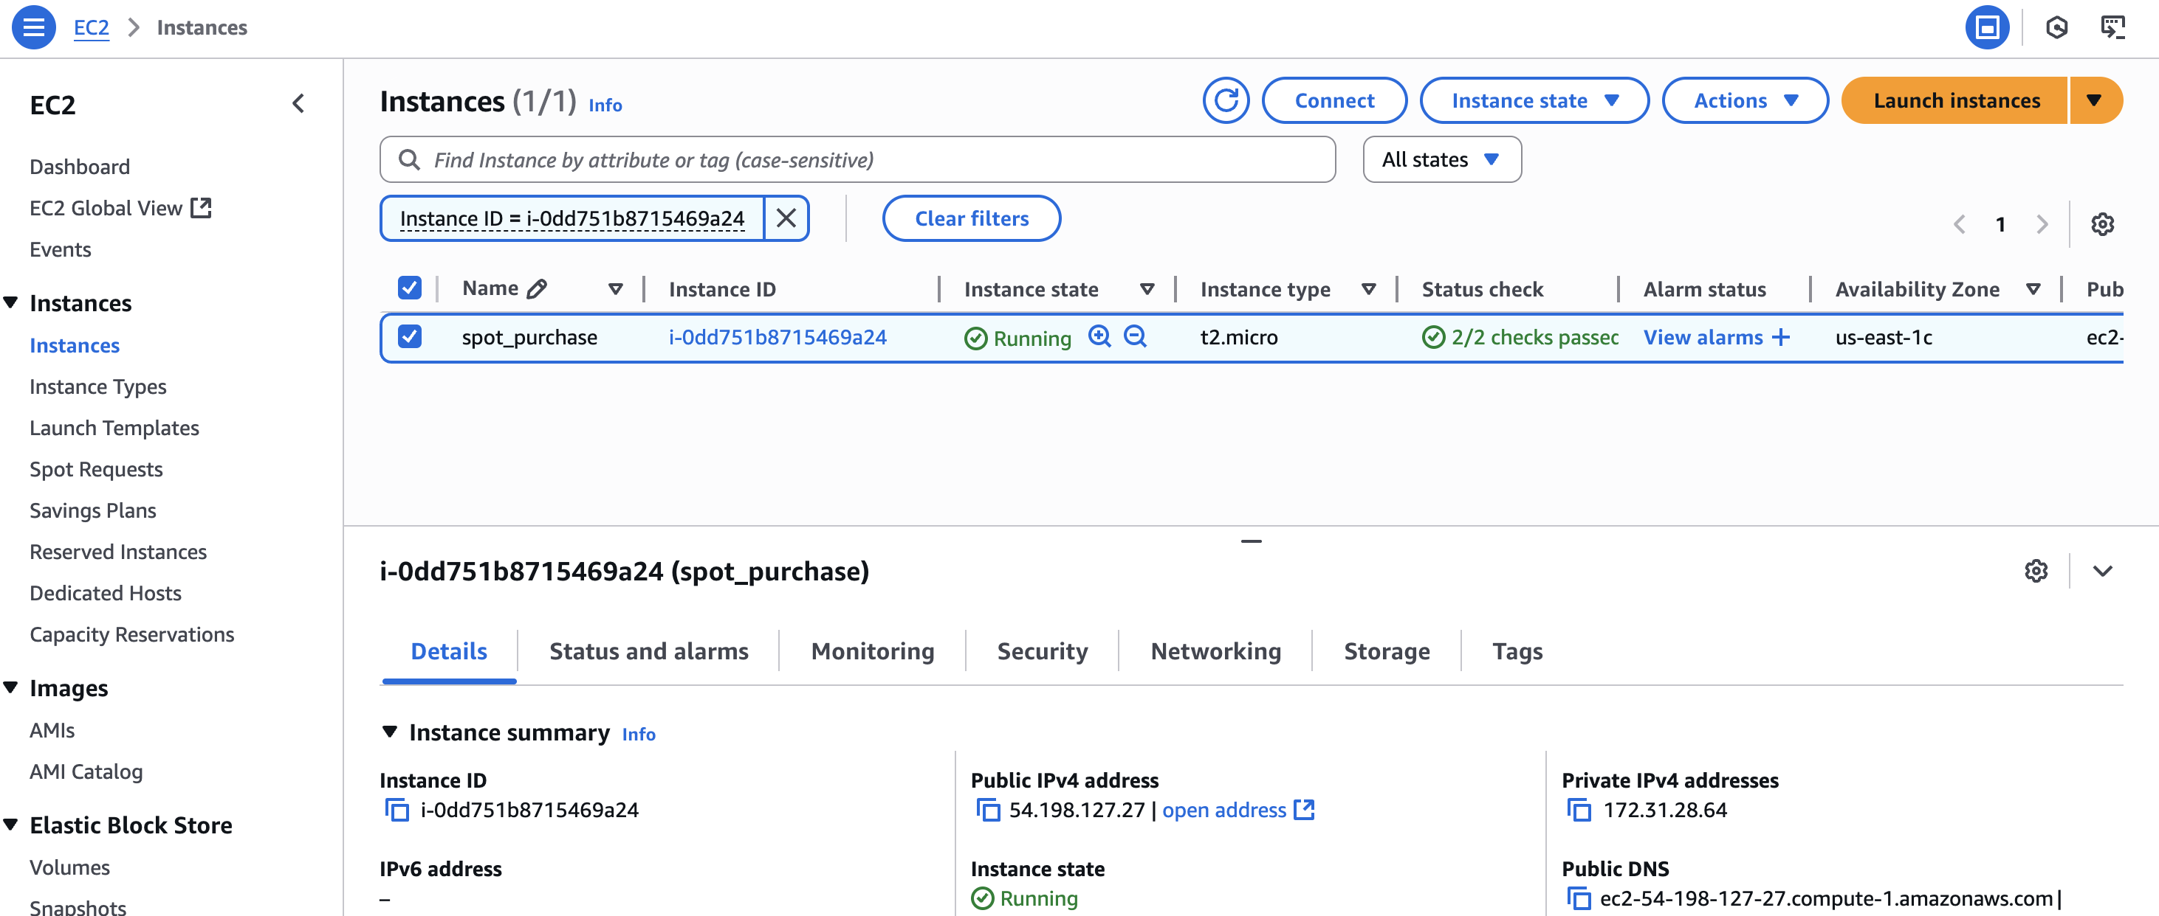

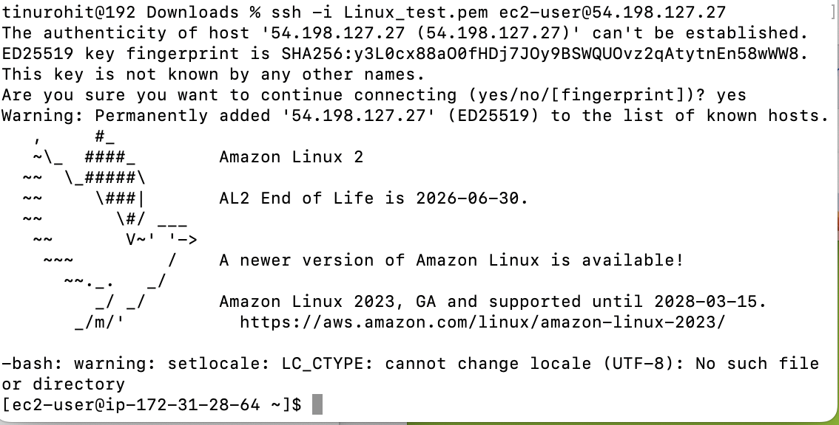

1. Enable Termination policy on ec2 created in Task 2.

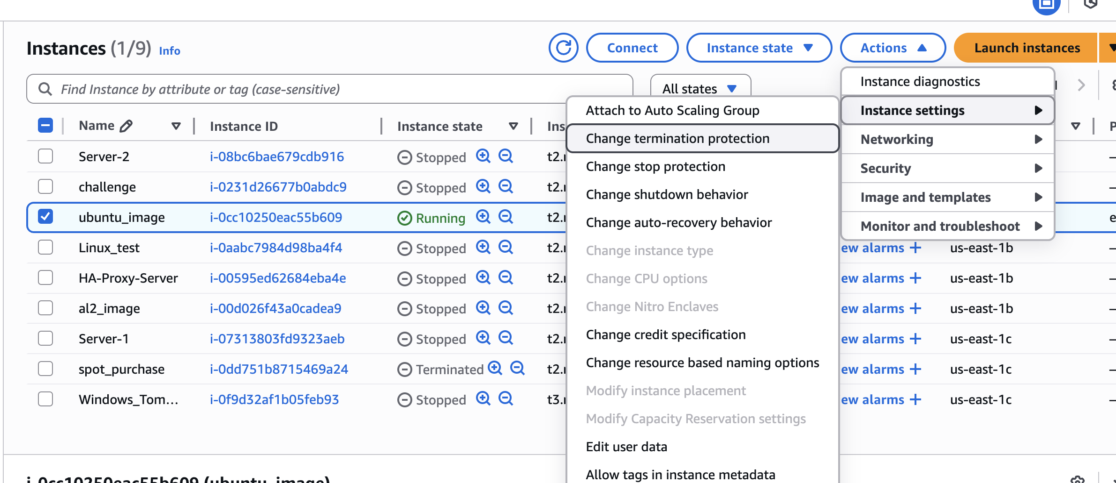

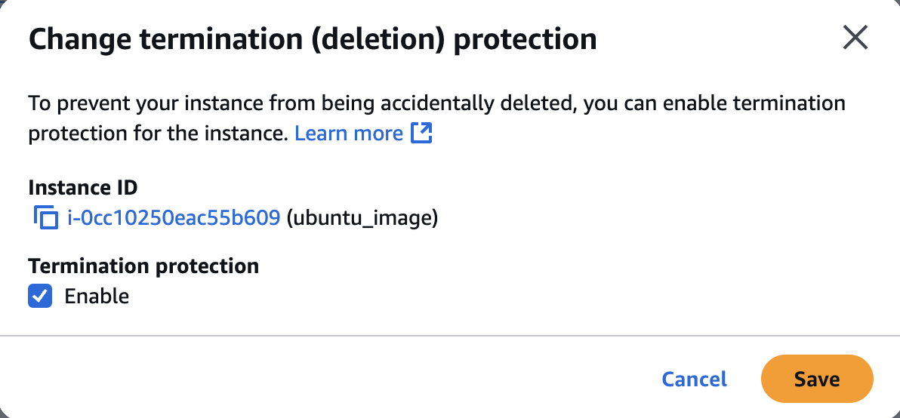

1. Launch one ec2 using Aws CLI.

curl "https://awscli.amazonaws.com/AWSCLIV2.pkg" -o "AWSCLIV2.pkg"

sudo installer -pkg AWSCLIV2.pkg -target /

